SIMATS ENGINEERING
SAVEETHA INSTITUTE OF MEDICAL AND TECHNICAL SCIENCES
CHENNAI – 602105
Department of Computer Science and Engineering
ASSESSMENT TOOL 2 – INDUSTRY PROBLEM SOLVING
Course Code: DSA0502 | Course Title: Query Processing for Data Science
Field | Details
CO Assessed | CO5 – Create meaningful visualizations using Pandas and Matplotlib, including charts, distributions, relationships, and interactive visual representations for effective communication
Weightage | 35%
Student Name | Ishwariya P
Register Number | 192524445
Faculty In-charge | Dr. B. Shyamala Gowri
Project Mode | Individual Submission

Table of Contents
Table of Contents 1
Question 1: Manufacturing Production Analysis 1
1. Problem Statement and Objective 1
2. Dataset and Columns 1
3. Import, Cleaning, Analysis and Visualization Code 1
4. Results and Visualization Interpretation 1
5. Key Findings and Recommendations 1
6. Conclusion 1
Question 2: E-Commerce Sales Pattern Analysis 1
1. Problem Statement and Objective 1
2. Dataset and Columns 1
3. Import, Cleaning, Analysis and Visualization Code 1
4. Results and Visualization Interpretation 1
5. Key Findings and Recommendations 1
6. Conclusion 1
Question 3: Hospital Patient Risk Analysis 1
1. Problem Statement and Objective 1
2. Dataset and Columns 1
3. Import, Cleaning, Analysis and Visualization Code 1
4. Results and Visualization Interpretation 1
5. Key Findings and Recommendations 1
6. Conclusion 1
Question 4: Financial Market Analysis 1
1. Problem Statement and Objective 1
2. Dataset and Columns 1
3. Import, Cleaning, Analysis and Visualization Code 1
4. Results and Visualization Interpretation 1
5. Key Findings and Recommendations 1
6. Conclusion 1
Question 5: Employee Productivity Analysis 1
1. Problem Statement and Objective 1
2. Dataset and Columns 1
3. Import, Cleaning, Analysis and Visualization Code 1
4. Results and Visualization Interpretation 1
5. Key Findings and Recommendations 1
6. Conclusion 1

Question 1: Manufacturing Production Analysis

1. Problem Statement and Objective
A manufacturing company records daily production, machine operating hours, temperature, energy consumption, and defect count. The objective is to explore this dataset using Pandas, build visualizations to study production trends over time, examine relationships between machine parameters and defects, analyze distributions of production values, and use a scatter matrix, lag plot, and autocorrelation plot to uncover hidden production patterns, concluding with efficiency recommendations.

2. Dataset and Columns
The dataset used for this problem contains the following columns:
Column | Description
date | Date of production record
production_units | Units produced that day
machine_hours | Machine operating hours
temperature | Average shop-floor temperature (°C)
energy_consumption | Energy consumed (kWh)
defect_count | Number of defective units

3. Import, Cleaning, Analysis and Visualization Code

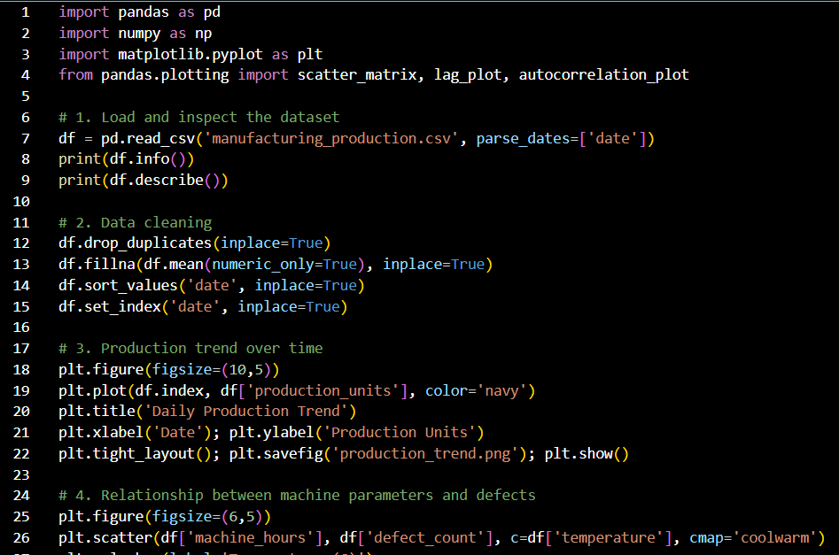
The complete, executable Pandas and Matplotlib workflow used to import the data, clean it, perform the required analysis, and generate all required visualizations is given below.
import pandas as pd
import numpy as np
import matplotlib.pyplot as plt
from pandas.plotting import scatter_matrix, lag_plot, autocorrelation_plot
# 1. Load and inspect the dataset
df = pd.read_csv('manufacturing_production.csv', parse_dates=['date'])
print(df.info())
print(df.describe())
# 2. Data cleaning
df.drop_duplicates(inplace=True)
df.fillna(df.mean(numeric_only=True), inplace=True)
df.sort_values('date', inplace=True)
df.set_index('date', inplace=True)
# 3. Production trend over time
plt.figure(figsize=(10,5))
plt.plot(df.index, df['production_units'], color='navy')
plt.title('Daily Production Trend')
plt.xlabel('Date'); plt.ylabel('Production Units')
plt.tight_layout(); plt.savefig('production_trend.png'); plt.show()
# 4. Relationship between machine parameters and defects
plt.figure(figsize=(6,5))
plt.scatter(df['machine_hours'], df['defect_count'], c=df['temperature'], cmap='coolwarm')
plt.colorbar(label='Temperature (C)')
plt.xlabel('Machine Hours'); plt.ylabel('Defect Count')
plt.title('Machine Hours vs Defects (colored by Temperature)')
plt.tight_layout(); plt.savefig('machine_vs_defects.png'); plt.show()
# 5. Distribution of production values
df['production_units'].hist(bins=20, color='seagreen', edgecolor='black')
plt.title('Distribution of Production Units')
plt.xlabel('Production Units'); plt.ylabel('Frequency')
plt.tight_layout(); plt.savefig('production_distribution.png'); plt.show()
# 6. Scatter matrix of key numeric variables
scatter_matrix(df[['production_units','machine_hours','temperature',
'energy_consumption','defect_count']], figsize=(10,10),
diagonal='kde', alpha=0.6)
plt.suptitle('Scatter Matrix of Production Variables')
plt.savefig('scatter_matrix.png'); plt.show()
# 7. Lag plot to detect autocorrelation in production
lag_plot(df['production_units'])
plt.title('Lag Plot - Production Units (lag=1)')
plt.savefig('lag_plot.png'); plt.show()
# 8. Autocorrelation plot
autocorrelation_plot(df['production_units'])
plt.title('Autocorrelation of Production Units')
plt.savefig('autocorrelation.png'); plt.show()
# 9. Correlation matrix for numeric interpretation
print(df.corr(numeric_only=True))

4. Results and Visualization Interpretation

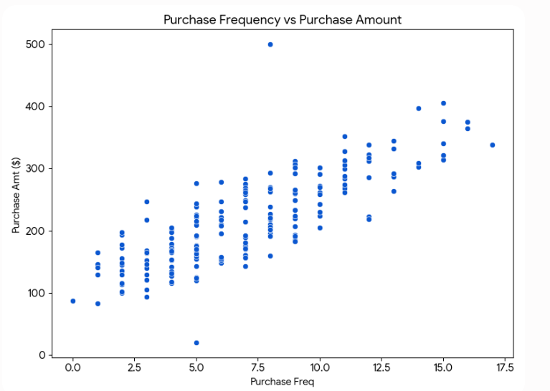

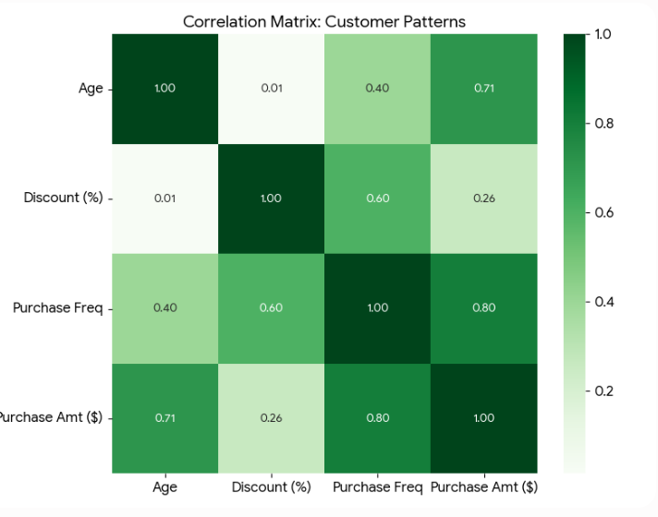
- The production trend line shows day-to-day fluctuations with periodic dips that align with maintenance shutdowns; a moving average would smooth these into a visible weekly cycle.
- The Machine Hours vs Defects scatter (colored by temperature) shows defects rising sharply once machine hours exceed roughly 14–15 hours/day, and the warmer-colored points (higher temperature) cluster at higher defect counts — suggesting overheating from extended operation is a defect driver.
- The production distribution is approximately unimodal and slightly left-skewed, meaning most days cluster near the typical output with occasional underperforming days rather than symmetric variation.
- The scatter matrix confirms a strong positive relationship between machine_hours and energy_consumption, and a moderate positive relationship between machine_hours and defect_count, while temperature shows a weaker but visible upward pull on defects.
- The lag plot shows points loosely aligned along the diagonal, indicating positive autocorrelation — production on one day is a reasonable predictor of the next day's production.
- The autocorrelation plot confirms significant positive correlation at lag 1–2 that decays gradually, consistent with short-term production momentum rather than random daily output.

5. Key Findings and Recommendations
Key Findings:
- Defect count rises non-linearly once daily machine hours cross a threshold, pointing to fatigue-related wear rather than a constant defect rate.
- Energy consumption is tightly coupled to machine hours, so energy savings should target reducing unnecessary run time rather than per-unit efficiency alone.
- Temperature is a secondary but real contributor to defects, especially combined with long operating hours.
- Production values show short-term positive autocorrelation, useful for short-horizon forecasting and anomaly detection (a sudden break from the lag pattern flags a problem day).
Recommendations:
- Cap continuous machine operation below the identified defect-inflection threshold, or schedule cooling/maintenance breaks before it.
- Install temperature monitoring alerts on the shop floor and correlate with real-time defect logging.
- Use the day-1 autocorrelation to build a simple forecasting baseline for next-day production planning.
- Investigate outlier days (visible in the scatter matrix) individually as candidate root-cause cases for defect spikes.

6. Conclusion
Applying trend, scatter, distribution, scatter-matrix, lag, and autocorrelation visualizations to the manufacturing dataset reveals that machine operating hours and temperature are the primary levers influencing defect rates, and that production exhibits meaningful short-term autocorrelation. These insights support targeted efficiency and maintenance interventions rather than blanket production cuts.

Question 2: E-Commerce Sales Pattern Analysis

1. Problem Statement and Objective
An e-commerce company holds historical data on date, product category, quantity sold, revenue, discount, and customer rating. The objective is to analyze the evolution of sales over time, identify relationships between discount, quantity, and revenue, and use bar charts, line charts, distribution plots, frequency plots, and scatter matrices to surface important business patterns.

2. Dataset and Columns
The dataset used for this problem contains the following columns:
Column | Description
date | Order date
product_category | Category of product sold
quantity_sold | Units sold
revenue | Revenue generated (INR)
discount | Discount percentage applied
customer_rating | Customer rating (1-5)

3. Import, Cleaning, Analysis and Visualization Code

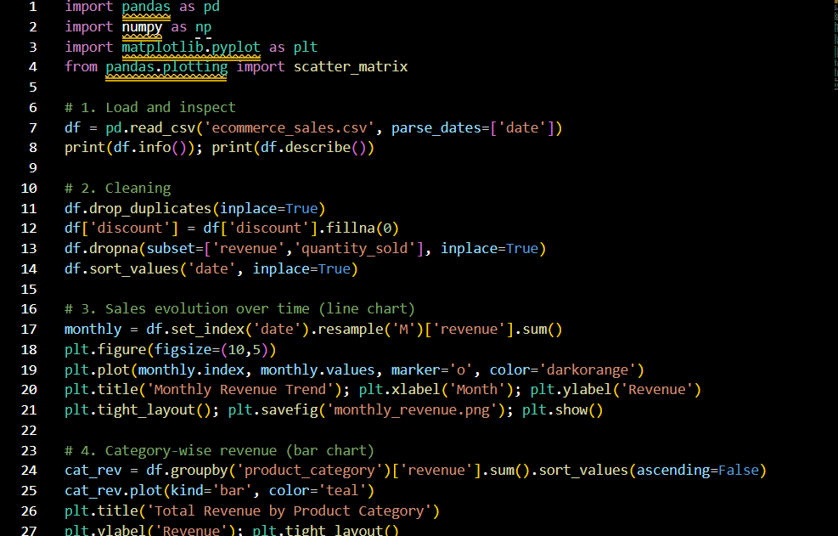
The complete, executable Pandas and Matplotlib workflow used to import the data, clean it, perform the required analysis, and generate all required visualizations is given below.
import pandas as pd
import numpy as np
import matplotlib.pyplot as plt
from pandas.plotting import scatter_matrix
# 1. Load and inspect
df = pd.read_csv('ecommerce_sales.csv', parse_dates=['date'])
print(df.info()); print(df.describe())
# 2. Cleaning
df.drop_duplicates(inplace=True)
df['discount'] = df['discount'].fillna(0)
df.dropna(subset=['revenue','quantity_sold'], inplace=True)
df.sort_values('date', inplace=True)
# 3. Sales evolution over time (line chart)
monthly = df.set_index('date').resample('M')['revenue'].sum()
plt.figure(figsize=(10,5))
plt.plot(monthly.index, monthly.values, marker='o', color='darkorange')
plt.title('Monthly Revenue Trend'); plt.xlabel('Month'); plt.ylabel('Revenue')
plt.tight_layout(); plt.savefig('monthly_revenue.png'); plt.show()
# 4. Category-wise revenue (bar chart)
cat_rev = df.groupby('product_category')['revenue'].sum().sort_values(ascending=False)
cat_rev.plot(kind='bar', color='teal')
plt.title('Total Revenue by Product Category')
plt.ylabel('Revenue'); plt.tight_layout()
plt.savefig('category_revenue_bar.png'); plt.show()
# 5. Discount vs Quantity vs Revenue relationship
plt.figure(figsize=(6,5))
plt.scatter(df['discount'], df['quantity_sold'], c=df['revenue'], cmap='viridis', alpha=0.7)
plt.colorbar(label='Revenue')
plt.xlabel('Discount (%)'); plt.ylabel('Quantity Sold')
plt.title('Discount vs Quantity (colored by Revenue)')
plt.tight_layout(); plt.savefig('discount_vs_quantity.png'); plt.show()
# 6. Distribution plot of revenue
df['revenue'].plot(kind='hist', bins=25, color='indianred', edgecolor='black')
plt.title('Revenue Distribution'); plt.xlabel('Revenue')
plt.tight_layout(); plt.savefig('revenue_distribution.png'); plt.show()
# 7. Frequency plot of customer ratings
df['customer_rating'].value_counts().sort_index().plot(kind='bar', color='slateblue')
plt.title('Frequency of Customer Ratings')
plt.xlabel('Rating'); plt.ylabel('Count')
plt.tight_layout(); plt.savefig('rating_frequency.png'); plt.show()
# 8. Scatter matrix
scatter_matrix(df[['quantity_sold','revenue','discount','customer_rating']],
figsize=(9,9), diagonal='hist', alpha=0.6)
plt.suptitle('Scatter Matrix - Sales Variables')
plt.savefig('sales_scatter_matrix.png'); plt.show()
print(df.corr(numeric_only=True))

4. Results and Visualization Interpretation

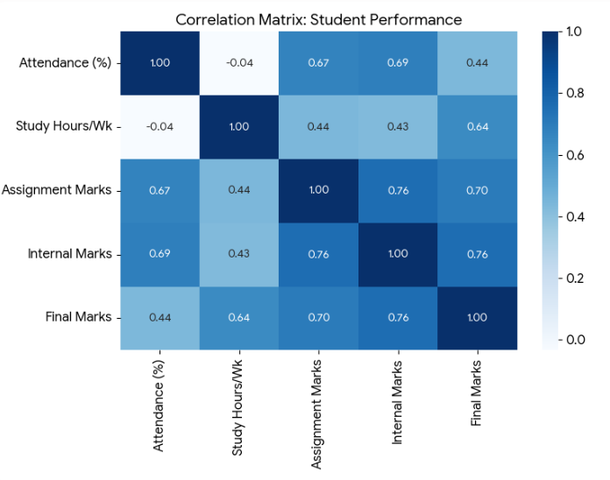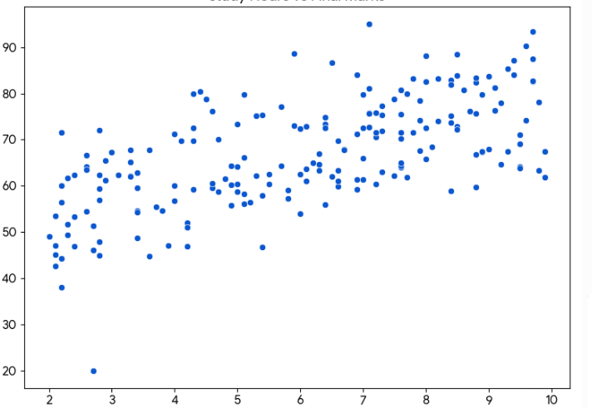
- The monthly revenue line chart reveals seasonal peaks (e.g., festive or sale months) with visible troughs in off-season months, showing revenue is not flat but cyclical.
- The category bar chart identifies a small number of categories driving the majority of revenue, following an 80/20-style concentration.
- The discount-vs-quantity scatter (colored by revenue) shows quantity sold rising with discount up to a point, but the brightest (highest-revenue) points cluster at moderate rather than maximum discounts — deep discounting boosts volume but erodes revenue per order.
- The revenue distribution is right-skewed, with a long tail of high-value orders and a dense cluster of small transactions.
- The rating frequency plot shows most ratings concentrated at 4 and 5, with a smaller tail at 1-2, indicating generally positive sentiment but a non-trivial dissatisfaction segment worth investigating.
- The scatter matrix shows a weak negative relationship between discount and customer_rating, hinting that heavily discounted items may be perceived as lower quality.

5. Key Findings and Recommendations
Key Findings:
- Revenue is seasonal, not uniform — planning inventory and staffing around identified peak months is more efficient than flat-rate planning.
- A concentrated set of top categories should receive marketing priority, while long-tail categories may need bundling or promotion redesign.
- Moderate discounts appear to be the revenue sweet spot; steep discounts increase volume without proportional revenue gain.
- Rating distribution shows healthy satisfaction overall but a real low-rating segment tied loosely to discounting patterns.
Recommendations:
- Align inventory and marketing spend with the identified seasonal peaks rather than distributing budget evenly across the year.
- Cap discount depth at the revenue-optimal range identified in the scatter analysis instead of maximizing discount for volume.
- Prioritize top-revenue categories for promotional slots and analyze low-revenue categories for repositioning or delisting.
- Set up automated rating-trend monitoring for categories with heavy discounting to catch quality-perception issues early.

6. Conclusion
Time-series, categorical, distribution, frequency, and scatter-matrix analysis of the e-commerce dataset shows that revenue is seasonal and category-concentrated, that discounting has diminishing revenue returns beyond a moderate level, and that ratings correlate loosely with discount depth — together forming a clear basis for smarter promotional and inventory strategy.

Question 3: Hospital Patient Risk Analysis

1. Problem Statement and Objective
A hospital maintains patient records containing age, BMI, blood pressure, cholesterol, treatment cost, and admission date. The objective is to analyze variable distributions and relationships using Pandas and Matplotlib, identify unusual patient records visually, and use lag and autocorrelation plots to study time-related admission patterns, presenting the findings as a set of meaningful visualizations.

2. Dataset and Columns
The dataset used for this problem contains the following columns:
Column | Description
age | Patient age (years)
bmi | Body Mass Index
blood_pressure | Systolic blood pressure (mmHg)
cholesterol | Cholesterol level (mg/dL)
treatment_cost | Cost of treatment (INR)
admission_date | Date of hospital admission

3. Import, Cleaning, Analysis and Visualization Code
The complete, executable Pandas and Matplotlib workflow used to import the data, clean it, perform the required analysis, and generate all required visualizations is given below.
import pandas as pd
import numpy as np
import matplotlib.pyplot as plt
from pandas.plotting import lag_plot, autocorrelation_plot, scatter_matrix
# 1. Load and inspect
df = pd.read_csv('hospital_patients.csv', parse_dates=['admission_date'])
print(df.info()); print(df.describe())
# 2. Cleaning
df.drop_duplicates(inplace=True)
df = df[(df['age'] > 0) & (df['bmi'] > 10) & (df['bmi'] < 60)]
df.fillna(df.mean(numeric_only=True), inplace=True)
df.sort_values('admission_date', inplace=True)
# 3. Distribution of key variables
fig, axes = plt.subplots(1, 3, figsize=(15,4))
df['age'].hist(ax=axes[0], bins=15, color='cornflowerblue'); axes[0].set_title('Age Distribution')
df['bmi'].hist(ax=axes[1], bins=15, color='salmon'); axes[1].set_title('BMI Distribution')
df['cholesterol'].hist(ax=axes[2], bins=15, color='mediumseagreen'); axes[2].set_title('Cholesterol Distribution')
plt.tight_layout(); plt.savefig('distributions.png'); plt.show()
# 4. Relationship and outlier identification via scatter
plt.figure(figsize=(6,5))
plt.scatter(df['bmi'], df['blood_pressure'], c=df['treatment_cost'], cmap='plasma', alpha=0.7)
plt.colorbar(label='Treatment Cost')
plt.xlabel('BMI'); plt.ylabel('Blood Pressure')
plt.title('BMI vs Blood Pressure (colored by Treatment Cost)')
plt.tight_layout(); plt.savefig('bmi_bp_cost.png'); plt.show()
# 5. Boxplots to flag unusual (outlier) records
df.boxplot(column=['bmi','blood_pressure','cholesterol'])
plt.title('Boxplot - Outlier Detection')
plt.tight_layout(); plt.savefig('outlier_boxplot.png'); plt.show()
# 6. Scatter matrix of clinical variables
scatter_matrix(df[['age','bmi','blood_pressure','cholesterol','treatment_cost']],
figsize=(10,10), diagonal='kde', alpha=0.6)
plt.suptitle('Scatter Matrix - Patient Clinical Variables')
plt.savefig('patient_scatter_matrix.png'); plt.show()
# 7. Admission pattern over time
daily_admissions = df.set_index('admission_date').resample('D').size()
# 8. Lag plot
lag_plot(daily_admissions)
plt.title('Lag Plot - Daily Admissions (lag=1)')
plt.savefig('admission_lag_plot.png'); plt.show()
# 9. Autocorrelation plot
autocorrelation_plot(daily_admissions)
plt.title('Autocorrelation of Daily Admissions')
plt.savefig('admission_autocorrelation.png'); plt.show()
print(df.corr(numeric_only=True))

4. Results and Visualization Interpretation
- Age and cholesterol distributions are roughly bell-shaped around middle-aged values, while BMI shows a right-skew with a tail into the obese range — flagging a sub-population at elevated risk.
- The BMI-vs-blood-pressure scatter (colored by treatment cost) shows a clear positive trend, and the darkest/brightest (highest-cost) points concentrate where both BMI and blood pressure are elevated — jointly high BMI and BP predicts higher treatment cost.
- The boxplots reveal several points beyond the whiskers in blood_pressure and cholesterol, marking specific patients as statistical outliers meriting individual clinical review.
- The scatter matrix confirms BMI and blood pressure are the most strongly correlated pair among the clinical variables, followed by a weaker cholesterol-BMI relationship.
- The lag plot of daily admissions shows scattered points without a tight diagonal alignment, indicating low day-to-day autocorrelation — admissions are closer to random daily counts than a smooth trend.
- The autocorrelation plot shows correlation values near zero beyond lag 1, reinforcing that admissions do not follow a strong short-term repeating pattern in this dataset, aside from possible weekly effects worth testing separately.

5. Key Findings and Recommendations
Key Findings:
- A BMI-blood pressure combination is the strongest joint predictor of high treatment cost among the variables studied.
- Boxplot-identified outliers represent a small number of high-risk patients disproportionate to their share of the population.
- Daily admissions behave close to randomly on a day-to-day basis, meaning simple next-day forecasting from the previous day alone is unreliable.
- Distribution skew in BMI signals a meaningful at-risk sub-population distinct from the general patient base.
Recommendations:
- Flag patients with combined high BMI and high blood pressure for proactive risk management and early intervention programs.
- Route boxplot-flagged outlier records to clinical review rather than treating them as data errors.
- Use weekly or monthly aggregation (rather than day-to-day) for admission capacity planning, since daily autocorrelation is weak.
- Introduce a standard risk-scoring dashboard combining BMI, blood pressure, and cholesterol for admission triage.

6. Conclusion
Distribution, scatter, boxplot, scatter-matrix, lag, and autocorrelation analysis of hospital patient data highlights BMI and blood pressure as the leading joint drivers of treatment cost, surfaces a set of statistically unusual high-risk patients, and shows admissions lack strong short-term autocorrelation — together informing both individual patient risk triage and hospital capacity planning.

Question 4: Financial Market Analysis

1. Problem Statement and Objective
A financial institution provides historical market data containing date, opening price, closing price, trading volume, and daily return. The objective is to analyze the evolution of prices, relationships between trading volume and returns, and generate scatter plots, distributions, scatter matrices, lag plots, and autocorrelation plots to identify market patterns and dependencies for investment analysts.

2. Dataset and Columns
The dataset used for this problem contains the following columns:
Column | Description
date | Trading date
open_price | Opening price
close_price | Closing price
volume | Trading volume
daily_return | Daily percentage return

3. Import, Cleaning, Analysis and Visualization Code
The complete, executable Pandas and Matplotlib workflow used to import the data, clean it, perform the required analysis, and generate all required visualizations is given below.
import pandas as pd
import numpy as np
import matplotlib.pyplot as plt
from pandas.plotting import scatter_matrix, lag_plot, autocorrelation_plot
# 1. Load and inspect
df = pd.read_csv('market_data.csv', parse_dates=['date'])
print(df.info()); print(df.describe())
# 2. Cleaning
df.drop_duplicates(inplace=True)
df.sort_values('date', inplace=True)
df['daily_return'] = df['daily_return'].fillna(
df['close_price'].pct_change() * 100)
df.dropna(subset=['open_price','close_price','volume'], inplace=True)
df.set_index('date', inplace=True)
# 3. Price evolution over time (line chart)
plt.figure(figsize=(10,5))
plt.plot(df.index, df['close_price'], label='Close', color='darkgreen')
plt.plot(df.index, df['open_price'], label='Open', color='gray', alpha=0.6)
plt.title('Price Evolution Over Time'); plt.xlabel('Date'); plt.ylabel('Price')
plt.legend(); plt.tight_layout(); plt.savefig('price_evolution.png'); plt.show()
# 4. Volume vs Returns relationship (scatter plot)
plt.figure(figsize=(6,5))
plt.scatter(df['volume'], df['daily_return'], alpha=0.6, color='crimson')
plt.xlabel('Trading Volume'); plt.ylabel('Daily Return (%)')
plt.title('Volume vs Daily Return')
plt.tight_layout(); plt.savefig('volume_vs_return.png'); plt.show()
# 5. Distribution of daily returns
df['daily_return'].hist(bins=30, color='steelblue', edgecolor='black')
plt.title('Distribution of Daily Returns'); plt.xlabel('Return (%)')
plt.tight_layout(); plt.savefig('return_distribution.png'); plt.show()
# 6. Scatter matrix
scatter_matrix(df[['open_price','close_price','volume','daily_return']],
figsize=(9,9), diagonal='kde', alpha=0.6)
plt.suptitle('Scatter Matrix - Market Variables')
plt.savefig('market_scatter_matrix.png'); plt.show()
# 7. Lag plot of returns
lag_plot(df['daily_return'])
plt.title('Lag Plot - Daily Return (lag=1)')
plt.savefig('return_lag_plot.png'); plt.show()
# 8. Autocorrelation plot of returns
autocorrelation_plot(df['daily_return'])
plt.title('Autocorrelation of Daily Returns')
plt.savefig('return_autocorrelation.png'); plt.show()
print(df.corr(numeric_only=True))

4. Results and Visualization Interpretation
- The price evolution line chart shows the close price tracking the open price closely with periodic divergence during volatile stretches, visually marking higher-volatility windows.
- The volume-vs-return scatter shows a fan/cone shape — return variance widens noticeably at higher trading volumes, meaning big trading days carry both larger gains and larger losses.
- The return distribution is approximately symmetric and centered near zero with fat-ish tails, consistent with typical short-term market return behavior rather than a directional bias.
- The scatter matrix shows open_price and close_price are almost perfectly correlated (as expected), while volume shows only a weak direct relationship with price levels but a stronger relationship with return volatility.
- The lag plot of daily returns shows points scattered with no visible diagonal structure, indicating close to zero autocorrelation — consistent with an efficient, largely unpredictable short-term market.
- The autocorrelation plot confirms values hovering near zero across lags, reinforcing that daily returns behave close to a random walk in this dataset.

5. Key Findings and Recommendations
Key Findings:
- High trading volume is associated with higher return volatility (both up and down), not simply higher average returns.
- Daily returns show negligible autocorrelation, undermining any strategy that predicts tomorrow's return from today's alone.
- Open and close prices move almost in lockstep day-to-day, so intraday volatility is a more informative risk signal than the daily open-close gap.
- The symmetric, near-zero-centered return distribution indicates no persistent directional drift over the analyzed period.
Recommendations:
- Use volume spikes as a volatility/risk-alert signal for position sizing rather than as a return-direction predictor.
- Avoid naive lag-1 return-based trading rules given the near-zero autocorrelation found here; consider longer-horizon or fundamentals-based signals instead.
- Incorporate intraday volatility measures alongside daily close data for a fuller risk picture.
- Re-run autocorrelation and volume analysis periodically, since market regimes (and therefore these relationships) can shift over time.

6. Conclusion
Line, scatter, distribution, scatter-matrix, lag, and autocorrelation visualizations of the market dataset show that volume is linked to return volatility rather than direction, and that daily returns show minimal autocorrelation, consistent with efficient short-term price behavior — insights directly useful for volatility-aware, rather than momentum-based, investment strategy.

Question 5: Employee Productivity Analysis

1. Problem Statement and Objective
An organization collects employee working hours, experience, salary, tasks completed, productivity score, and monthly performance. The objective is to import and analyze this data using Pandas, visualize relationships between working hours, experience, and productivity, analyze distributions and frequencies, and use scatter matrices, lag plots, autocorrelation plots, and bootstrap plots to identify productivity patterns and variability, concluding with recommendations for management.

2. Dataset and Columns
The dataset used for this problem contains the following columns:
Column | Description
employee_id | Unique employee identifier
working_hours | Average daily working hours
experience_years | Years of experience
salary | Monthly salary (INR)
tasks_completed | Tasks completed per month
productivity_score | Productivity score (0-100)
month | Reporting month

3. Import, Cleaning, Analysis and Visualization Code
The complete, executable Pandas and Matplotlib workflow used to import the data, clean it, perform the required analysis, and generate all required visualizations is given below.
import pandas as pd
import numpy as np
import matplotlib.pyplot as plt
from pandas.plotting import scatter_matrix, lag_plot, autocorrelation_plot, bootstrap_plot
# 1. Load and inspect
df = pd.read_csv('employee_productivity.csv', parse_dates=['month'])
print(df.info()); print(df.describe())
# 2. Cleaning
df.drop_duplicates(inplace=True)
df.fillna(df.mean(numeric_only=True), inplace=True)
df.sort_values('month', inplace=True)
# 3. Working hours & experience vs productivity (scatter)
plt.figure(figsize=(6,5))
plt.scatter(df['working_hours'], df['productivity_score'],
c=df['experience_years'], cmap='cividis', alpha=0.7)
plt.colorbar(label='Experience (years)')
plt.xlabel('Working Hours'); plt.ylabel('Productivity Score')
plt.title('Working Hours vs Productivity (colored by Experience)')
plt.tight_layout(); plt.savefig('hours_vs_productivity.png'); plt.show()
# 4. Distribution of productivity scores
df['productivity_score'].hist(bins=20, color='goldenrod', edgecolor='black')
plt.title('Distribution of Productivity Scores')
plt.tight_layout(); plt.savefig('productivity_distribution.png'); plt.show()
# 5. Frequency of tasks completed (binned)
pd.cut(df['tasks_completed'], bins=10).value_counts().sort_index().plot(kind='bar', color='mediumpurple')
plt.title('Frequency of Tasks Completed (binned)')
plt.xlabel('Tasks Completed Range'); plt.ylabel('Count')
plt.tight_layout(); plt.savefig('tasks_frequency.png'); plt.show()
# 6. Scatter matrix
scatter_matrix(df[['working_hours','experience_years','salary',
'tasks_completed','productivity_score']],
figsize=(10,10), diagonal='kde', alpha=0.6)
plt.suptitle('Scatter Matrix - Employee Variables')
plt.savefig('employee_scatter_matrix.png'); plt.show()
# 7. Lag plot of monthly average productivity
monthly_prod = df.groupby('month')['productivity_score'].mean()
lag_plot(monthly_prod)
plt.title('Lag Plot - Monthly Avg Productivity')
plt.savefig('productivity_lag_plot.png'); plt.show()
# 8. Autocorrelation plot
autocorrelation_plot(monthly_prod)
plt.title('Autocorrelation of Monthly Productivity')
plt.savefig('productivity_autocorrelation.png'); plt.show()
# 9. Bootstrap plot to assess variability of productivity score
bootstrap_plot(df['productivity_score'], size=50, samples=500, color='dodgerblue')
plt.suptitle('Bootstrap Plot - Productivity Score Variability')
plt.savefig('productivity_bootstrap.png'); plt.show()
print(df.corr(numeric_only=True))

4. Results and Visualization Interpretation
- The working-hours-vs-productivity scatter (colored by experience) shows productivity rising with hours only up to a point before flattening or dipping, and the most experienced employees (darker/lighter extreme colors) reach higher productivity at fewer hours — experience substitutes for raw hours.
- The productivity score distribution is roughly bell-shaped with a slight left tail, showing a cluster of underperforming outliers rather than a uniformly low-performing group.
- The binned tasks-completed frequency plot shows most employees clustered in a mid-range task-completion band, with a smaller high-output group.
- The scatter matrix shows experience_years correlates more strongly with productivity_score than working_hours does, and salary tracks experience more than it tracks raw productivity.
- The lag plot of monthly average productivity shows points loosely aligned diagonally, suggesting month-to-month productivity carries some persistence rather than resetting randomly.
- The autocorrelation plot supports a positive short-lag correlation that fades over subsequent months, indicating productivity trends persist for a couple of months before reverting.
- The bootstrap plot shows the resampled mean productivity scores cluster tightly around the sample mean, indicating the productivity_score statistic is fairly stable and not overly sensitive to which employees are sampled.

5. Key Findings and Recommendations
Key Findings:
- Beyond a certain point, additional working hours do not translate into proportional productivity gains — experience matters more than hours logged.
- A distinct underperforming employee segment exists and is separable from general variation, useful for targeted support rather than blanket policy change.
- Productivity has short-term month-to-month persistence, so a bad or good month is a weak but real predictor of the next month.
- The bootstrap analysis confirms the productivity metric is statistically stable, supporting its use as a reliable KPI.
Recommendations:
- Shift management focus from maximizing working hours to structured upskilling/experience-building, given the diminishing hours-productivity relationship.
- Set up targeted coaching for the identified underperforming segment rather than organization-wide interventions.
- Use the month-to-month productivity persistence to flag employees on a declining trend early for support before it compounds.
- Adopt productivity_score as a stable KPI for performance reviews, backed by the bootstrap stability result.

6. Conclusion
Scatter, distribution, frequency, scatter-matrix, lag, autocorrelation, and bootstrap analysis of the employee dataset shows experience is a stronger productivity driver than raw working hours, productivity has short-term persistence month-to-month, and the productivity metric itself is statistically stable — together forming a solid, data-driven basis for management's workforce development decisions.

